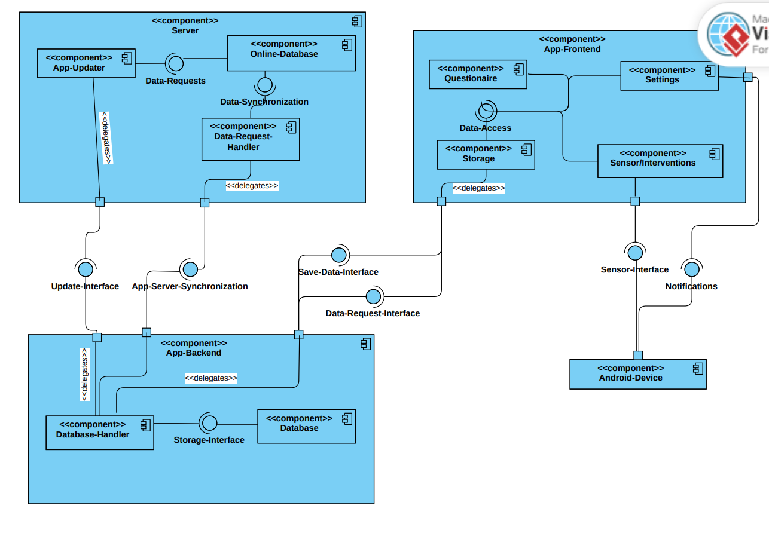

The presented component diagram sketches our current app design. At the moment, we are planning to use three main components. The first one will the app itself being the frontend with all the different activities as components. Additionally, we need the local backend which deals with data storing and as well as with synchronising the local storage with the server-sided database. The server will also store data especially the data we want to provide to the customer.
The App itself has three main components and one storage component. The storage component will handle all the data access requests by the three other components of the app. This includes requesting data and saving data. For this the storage component provides an interface. Currently this interface is realized in a class called “DBHelper”. When any of the app’s components want to save or access data the DBHelper interface is used. For the DBHelper we used the Singleton pattern.
Hence to realize the user-stories about the recording of the effective wellbeing, the questionnaire component will record the answers from the user and then uses the Data-Access Interface. Same goes with the sensor/intervention’s component. When the user wants to record an intervention and this includes sensor data, the saved data will also be stored using the same interface. To record sensor data the sensor interface provided by the android device itself is used.
The app’s backend is designed with two sub-components. One is the database itself and one being the database-handler which handles requests and also deals with synchronization with the server. The database handler provides two interfaces for the app-frontend. One for data-request, one for saving data. The Database Handler then always saves the newly incoming data in the local database using the storage interface provided by the database. When the frontend requests data from the backend, the database handler then access the locally saved data from the database and provides it to the frontend.
Apart from the frontend-backend communication, the database-handler also communicates with our server. Here the main tasks are updating the local data and uploading monitored sensor data and questionnaire questions to provide this information for the customer.
The App-Server-Synchronization will use IDs to make the communication and information pseudonymized. The main part of this communication will be the upload of the recorded data of the user which has been monitored during interventions or when the user decided to the app to record the user’s data. Additionally, the local Database helper can use the by the server provided interface to check if there are possible updates, a new algorithm or new questions which should be then added to the questionnaire component.
The reason why we chose this architecture is mainly because the app needs to work offline while the researcher should still be able to access data collected by the app.
They way we want to archive this duality is by having two databases. One being managed locally on the users’s device and one database on the server which will synchronize every time the user is reconnecting to the internet. Having one database locally which saves all the data we ensure that will can always show our data visually and the user can always answer the questionnaire no matter if he is connected to our server or not.
Because we also upload our data anonymously to our server, we can provide the research our collected data easily. Additionally, we have a way to communicate with all user’s at the same time when new features need to be uploaded.
This way we can implement all the requirements dealing with the data collection. Additionally, we ensure that interventions will be proposed as intended and all recordings will also be saved locally and later online for further analysis. Because the user should be able to see all interventions he recorded we save those data locally as well.

